Power of a Point
# Source: AI Source: Provided by: [Data Path: Persons Table -> ID Column: 1, Name_En Column: Motasem Essam] -> From: [ChatGPT] on [7/25/2026]
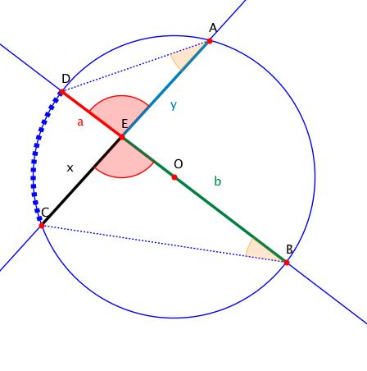
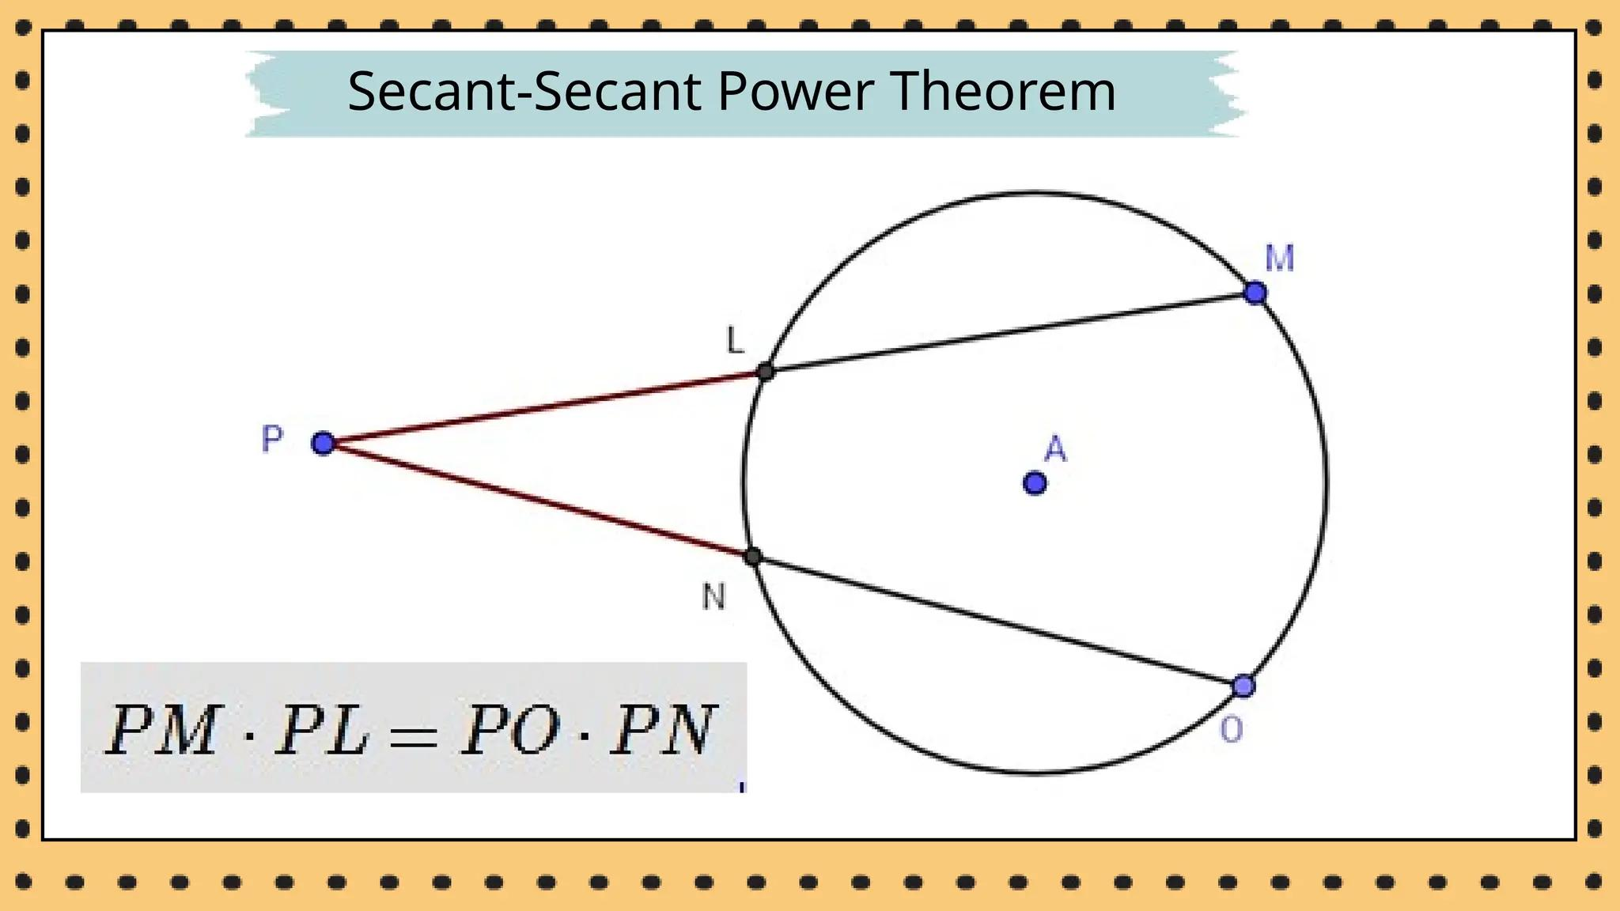
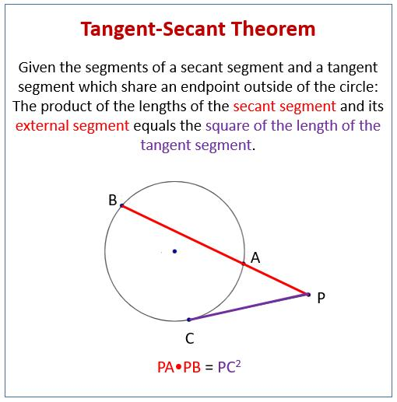
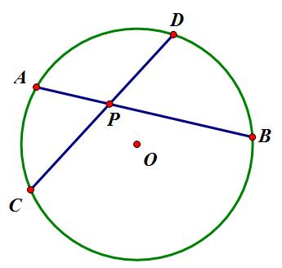

Definition
# Source: AI Source: Provided by: [Data Path: Persons Table -> ID Column: 1, Name_En Column: Motasem Essam] -> From: [ChatGPT] on [7/25/2026]
The Power of a Point is a numerical quantity that describes the relationship between a point and a circle.
For a point $P$and a circle with center $O$and radius $r$, the power of $P$is:
$$\boxed{Pow⁡\left(P\right)=PO^{2}-r^{2}}$$
The value indicates whether $P$is outside, on, or inside the circle.

Fundamental Concept
# Source: AI Source: Provided by: [Data Path: Persons Table -> ID Column: 1, Name_En Column: Motasem Essam] -> From: [ChatGPT] on [7/25/2026]
Let:
- $P$= a point
- $O$= center of the circle
- $r$= radius
- $PO=d$= distance from $P$to the center
Then:
$$\boxed{Pow⁡\left(P\right)=d^{2}-r^{2}}$$
Therefore:
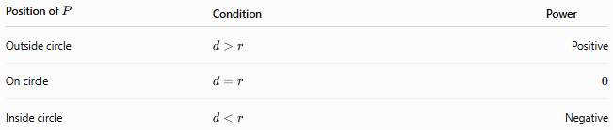
Position of $P$ | Condition | Power
Outside circle | $$d>r$$ | Positive
On circle | $$d=r$$ | $$0$$
Inside circle | $$d<r$$ | Negative

Geometric Meaning
# Source: AI Source: Provided by: [Data Path: Persons Table -> ID Column: 1, Name_En Column: Motasem Essam] -> From: [ChatGPT] on [7/25/2026]
The power can also be obtained from the products of distances along a line through $P$.
This gives different forms depending on where $P$is located.
Point outside the circle
If a secant from $P$intersects the circle at $A$and $B$:
$$P-A-B$$
then:
$$\boxed{Pow⁡\left(P\right)=PA⋅PB}$$
Point inside the circle
If two chords intersect at $P$, with endpoints $A,B$on one chord and $C,D$on the other:
$$\boxed{Pow⁡\left(P\right)=-PA⋅PB}$$
and
$$\boxed{PA⋅PB=PC⋅PD}$$

Power of a Point Formula
# Source: AI Source: Provided by: [Data Path: Persons Table -> ID Column: 1, Name_En Column: Motasem Essam] -> From: [ChatGPT] on [7/25/2026]
For a circle:
$$\boxed{Pow⁡\left(P\right)=PO^{2}-r^{2}}$$
This is the fundamental formula.
If $PO=d$:
$$\boxed{Pow⁡\left(P\right)=d^{2}-r^{2}}$$

Point Outside the Circle
# Source: AI Source: Provided by: [Data Path: Persons Table -> ID Column: 1, Name_En Column: Motasem Essam] -> From: [ChatGPT] on [7/25/2026]
When $P$is outside the circle, the power is positive.
Secant form
For secant $PAB$:
$$\boxed{Pow⁡\left(P\right)=PA⋅PB}$$
where:
- $PA$= external portion
- $PB$= entire secant portion
Thus:
$$\boxed{PA⋅PB=PO^{2}-r^{2}}$$

Tangent Form
# Source: AI Source: Provided by: [Data Path: Persons Table -> ID Column: 1, Name_En Column: Motasem Essam] -> From: [ChatGPT] on [7/25/2026]
If $P$is outside the circle and $PT$is tangent at $T$, then:
$$\boxed{Pow⁡\left(P\right)=PT^{2}}$$
Therefore:
$$\boxed{PT^{2}=PO^{2}-r^{2}}$$
and:
$$\boxed{PT=\sqrt{PO^{2}-r^{2}}}$$
This is why the tangent length from an external point can be calculated directly from the power of the point.

Secant–Secant Theorem
# Source: AI Source: Provided by: [Data Path: Persons Table -> ID Column: 1, Name_En Column: Motasem Essam] -> From: [ChatGPT] on [7/25/2026]
If two secants originate from the same external point $P$:
$$P-A-B$$
and
$$P-C-D$$
then:
$$\boxed{PA⋅PB=PC⋅PD}$$
Both products represent the same power:
$$\boxed{Pow⁡\left(P\right)=PA⋅PB=PC⋅PD}$$

Tangent–Secant Theorem
# Source: AI Source: Provided by: [Data Path: Persons Table -> ID Column: 1, Name_En Column: Motasem Essam] -> From: [ChatGPT] on [7/25/2026]
If $PT$is tangent and $PAB$is a secant:
$$\boxed{PT^{2}=PA⋅PB}$$
Therefore:
$$\boxed{Pow⁡\left(P\right)=PT^{2}=PA⋅PB}$$

Point on the Circle
# Source: AI Source: Provided by: [Data Path: Persons Table -> ID Column: 1, Name_En Column: Motasem Essam] -> From: [ChatGPT] on [7/25/2026]
If $P$lies exactly on the circle:
$$PO=r$$
Therefore:
$$Pow⁡\left(P\right)=r^{2}-r^{2} \\ \boxed{Pow⁡\left(P\right)=0}$$
So a point has zero power exactly when it lies on the circle.

Point Inside the Circle
# Source: AI Source: Provided by: [Data Path: Persons Table -> ID Column: 1, Name_En Column: Motasem Essam] -> From: [ChatGPT] on [7/25/2026]
If $P$is inside the circle:
$$PO<r$$
Therefore:
$$PO^{2}-r^{2}<0$$
so:
$$\boxed{Pow⁡\left(P\right)<0}$$
If a chord $AB$passes through $P$:
$$\boxed{Pow⁡\left(P\right)=-PA⋅PB}$$
The negative sign is important when using the signed algebraic definition of power.

Intersecting Chords Theorem
# Source: AI Source: Provided by: [Data Path: Persons Table -> ID Column: 1, Name_En Column: Motasem Essam] -> From: [ChatGPT] on [7/25/2026]
When two chords intersect at an interior point $P$:
$$A-P-B$$
and
$$C-P-D$$
then:
$$\boxed{PA⋅PB=PC⋅PD}$$
This product is related to the power of $P$:
$$\boxed{Pow⁡\left(P\right)=-PA⋅PB}$$
under the signed-distance convention.
In elementary geometry, the positive product equality is usually emphasized:
$$\boxed{PA⋅PB=PC⋅PD}$$

Classification
# Source: AI Source: Provided by: [Data Path: Persons Table -> ID Column: 1, Name_En Column: Motasem Essam] -> From: [ChatGPT] on [7/25/2026]
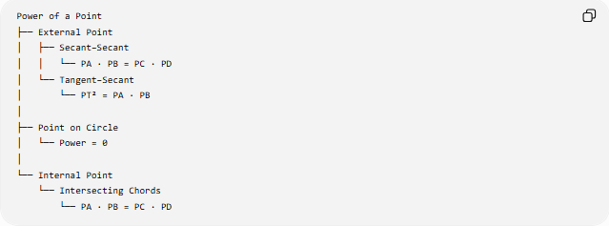
Power of a Point
├── External Point
│ ├── Secant–Secant
│ │ └── PA · PB = PC · PD
│ └── Tangent–Secant
│ └── PT² = PA · PB
│
├── Point on Circle
│ └── Power = 0
│
└── Internal Point
└── Intersecting Chords
└── PA · PB = PC · PD

Example — Using Center and Radius
# Source: AI Source: Provided by: [Data Path: Persons Table -> ID Column: 1, Name_En Column: Motasem Essam] -> From: [ChatGPT] on [7/25/2026]
Suppose:
$$PO=10$$
and:
$$r=6$$
Then:
$$Pow⁡\left(P\right)={10}^{2}-6^{2} \\ =100-36 \\ \boxed{Pow⁡\left(P\right)=64}$$
Because the power is positive, $P$is outside the circle.
If $P$has a tangent to the circle, then:
$$PT^{2}=64$$
so:
$$\boxed{PT=8}$$

Example — Secant
# Source: AI Source: Provided by: [Data Path: Persons Table -> ID Column: 1, Name_En Column: Motasem Essam] -> From: [ChatGPT] on [7/25/2026]
Suppose an external point $P$has a secant with:
$$PA=4$$
and:
$$PB=16$$
Then:
$$Pow⁡\left(P\right)=PA⋅PB \\ =4\left(16\right) \\ \boxed{Pow⁡\left(P\right)=64}$$
Therefore, any other secant from $P$must produce a product of $64$.

Example — Two Secants
# Source: AI Source: Provided by: [Data Path: Persons Table -> ID Column: 1, Name_En Column: Motasem Essam] -> From: [ChatGPT] on [7/25/2026]
Suppose:
$$PA=3, PB=15$$
and another secant has:
$$PC=5$$
Then:
$$PA⋅PB=PC⋅PD \\ 3\left(15\right)=5\left(PD\right) \\ 45=5PD \\ \boxed{PD=9}$$
Both secants give the same power:
$$\boxed{Pow⁡\left(P\right)=45}$$

Coordinate Geometry
# Source: AI Source: Provided by: [Data Path: Persons Table -> ID Column: 1, Name_En Column: Motasem Essam] -> From: [ChatGPT] on [7/25/2026]
For a circle:
$${\left(x-h\right)}^{2}+{\left(y-k\right)}^{2}=r^{2}$$
and a point:
$$P=\left(x_{0} , y_{0}\right)$$
the power of $P$is:
$$\boxed{Pow⁡\left(P\right)={\left(x_{0}-h\right)}^{2}+{\left(y_{0}-k\right)}^{2}-r^{2}}$$
This is simply:
$$PO^{2}-r^{2}$$
expressed using coordinates.
Example
Circle:
$${\left(x-2\right)}^{2}+{\left(y-3\right)}^{2}=25$$
Point:
$$P=\left(8 , 6\right)$$
Then:
$$Pow⁡\left(P\right)={\left(8-2\right)}^{2}+{\left(6-3\right)}^{2}-25 \\ =36+9-25 \\ \boxed{20}$$
The positive value means the point is outside the circle.

Relationship to Tangency
# Source: AI Source: Provided by: [Data Path: Persons Table -> ID Column: 1, Name_En Column: Motasem Essam] -> From: [ChatGPT] on [7/25/2026]
The power of a point provides a direct connection between a point and its tangent length.
For an external point:
$$\boxed{PT=\sqrt{Pow⁡\left(P\right)}}$$
Therefore:
$$\boxed{Pow⁡\left(P\right)=PT^{2}}$$
This makes power especially useful for tangent-length problems.

Relationship to Secancy
# Source: AI Source: Provided by: [Data Path: Persons Table -> ID Column: 1, Name_En Column: Motasem Essam] -> From: [ChatGPT] on [7/25/2026]
Power of a point is closely connected to secancy.
For an external point:
$$\boxed{Pow⁡\left(P\right)=PA⋅PB}$$
Thus, the product of the external secant segment and the entire secant segment remains constant for every secant drawn from $P$.
This is the mathematical basis of the Secant–Secant Theorem.

Power of a Point vs. Tangency vs. Secancy
# Source: AI Source: Provided by: [Data Path: Persons Table -> ID Column: 1, Name_En Column: Motasem Essam] -> From: [ChatGPT] on [7/25/2026]
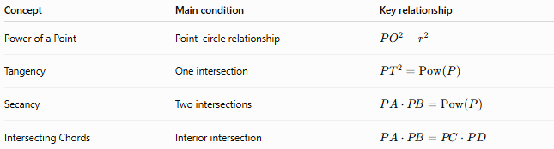
Concept | Main condition | Key relationship
Power of a Point | Point–circle relationship | $$PO^{2}-r^{2}$$
Tangency | One intersection | $$PT^{2}=Pow⁡\left(P\right)$$
Secancy | Two intersections | $$PA⋅PB=Pow⁡\left(P\right)$$
Intersecting Chords | Interior intersection | $$PA⋅PB=PC⋅PD$$

Important Properties
# Source: AI Source: Provided by: [Data Path: Persons Table -> ID Column: 1, Name_En Column: Motasem Essam] -> From: [ChatGPT] on [7/25/2026]
Property 1 — Constant value
For a fixed point $P$and circle, the power has one unique value regardless of which secant is used.
Property 2 — Zero power
$$\boxed{Pow⁡\left(P\right)=0}$$
if and only if $P$lies on the circle.
Property 3 — Positive power
$$\boxed{Pow⁡\left(P\right)>0}$$
when $P$is outside the circle.
Property 4 — Negative power
$$\boxed{Pow⁡\left(P\right)<0}$$
when $P$is inside the circle.
Property 5 — Tangent length
For an external point:
$$\boxed{PT=\sqrt{Pow⁡\left(P\right)}}$$

Applications
# Source: AI Source: Provided by: [Data Path: Persons Table -> ID Column: 1, Name_En Column: Motasem Essam] -> From: [ChatGPT] on [7/25/2026]
The Power of a Point is used in:
- Circle geometry
- Secant problems
- Tangent problems
- Intersecting chord problems
- Coordinate geometry
- Geometric constructions
- Computational geometry
- CAD and computer graphics
- Finding tangent lengths
- Determining relationships between points and circles

sKey Points
# Source: AI Source: Provided by: [Data Path: Persons Table -> ID Column: 1, Name_En Column: Motasem Essam] -> From: [ChatGPT] on [7/25/2026]
- The Power of a Point measures the relationship between a point and a circle.
- Its fundamental formula is:
$$\boxed{Pow⁡\left(P\right)=PO^{2}-r^{2}}$$
- Outside the circle, power is positive.
- On the circle, power is zero.
- Inside the circle, power is negative under the signed convention.
- For an external secant:
$$\boxed{Pow⁡\left(P\right)=PA⋅PB}$$
- For a tangent:
$$\boxed{Pow⁡\left(P\right)=PT^{2}}$$
- For two secants from the same external point:
$$\boxed{PA⋅PB=PC⋅PD}$$
- For intersecting chords:
$$\boxed{PA⋅PB=PC⋅PD}$$

Conclusion
# Source: AI Source: Provided by: [Data Path: Persons Table -> ID Column: 1, Name_En Column: Motasem Essam] -> From: [ChatGPT] on [7/25/2026]
Power of a Point is a fundamental circle-geometry concept that assigns a numerical value to a point relative to a circle. Its central formula,
$$\boxed{Pow⁡\left(P\right)=PO^{2}-r^{2}}$$
connects the point's distance from the center with tangent lengths, secants, and intersecting chords. It provides a unified way to understand several important circle theorems.

